Title: Scale-Aligned Comparison of Sum-Score and Latent-Variable Growth Models: Parameter Recovery under Correlated Uniqueness
abstract here

.
Keywords: word; another word; lower case except names

1 Introduction
Historically, sum scores have been widely used due to their simplicity and interpretability, which makes them favorable for replication and interdisciplinary communication purposes (Sijtsma et al., 2024b; Widaman & Revelle, 2024). When a set of items is approximately unidimensional, the sum score can provide a practical summary of the underlying construct (Sijtsma et al., 2024a) and even perform better in cross-validation across samples (Widaman & Revelle, 2024). These properties, however, rest on assumptions including uncorrelated errors and measurement invariance across occasions. Because sum-score does not separate measurement error at the latent level, their validity is often questioned, especially when evidence of construct validity is not fully disclosed (McNeish, 2024).
A latent variable model, specifically within the framework of factor analysis and broader structural equation modeling (SEM), is regarded as a rigorous alternative to the sum-score model (McNeish & Wolf, 2020). Its primary advantage lies in explicit modeling of measurement errors, which in turn enables procedures such as invariance testing and specification of residual covariances (McNeish, 2022). Nevertheless, latent variable model is more complex and estimates more parameters than sum score model and therefore requires larger sample sizes. In addition, latent variable modeling requires arbitrary identification constraints to establish the metric of latent variable, which further complicates communication among applied audiences (Sijtsma et al., 2024b).
The choice between sum scores and latent variables has long been a concern, and active debates have continued regarding the conditions under which each is acceptable and when the two approaches yield convergent or divergent conclusions (Edelsbrunner, 2022; McNeish, 2023, 2024; Mislevy, 2024; Sijtsma et al., 2024b; Widaman & Revelle, 2022). These debates, however, have focused heavily on cross-sectional designs. When the goal shifts from measuring a construct at a single occasion to measuring it across multiple time points in longitudinal data, the relationship between the two approaches has not yet been thoroughly explored.
Specifically, latent growth curve modeling (LGCM) is one of the most widely used models for analyzing longitudinal data to capture the growth trajectories (Bishop et al., 2015; Meredith & Tisak, 1990). To this end, the second-order LGCM (2-LGCM; Geiser et al., 2013), also called as curve-of-factors model (McArdle, 1988), analyzes the growth of latent factors while explicitly accounting for the measurement errors. Despite the advantages of incorporating residuals, applied studies have fitted first-order LGCMs (1-LGCM) more often using sum or mean scores (Isiordia & Ferrer, 2018).
Geiser and others (2013) ~~~. Leite (2007) directly compared these two models parameter estimates and found scale mismatch of them as . However, there are still two critical questions remain. First, their comparison did not place the two models on a single metric, so any discrepancy between them is not solely contributable to the model’s properties, but with confounding effects by the magnitude of scale itself. Since an identification constraint is asked for the scale of latent variable, the corresponding growth-related parameters (e.g., covariance of growth intercept and slope) will have different scales compared to them from the model with observed sum scores by aggregation, which made it difficult to compare estimates from both models directly.
Additionally, the influence of residual covariance across waves was not considered, even though such covariance occurs commonly in real settings. More specifically, when the same indicators are observed repeatedly across multiple occasions, its residual at one wave tends to correlate with its residual at adjacent time points, referred as correlated uniqueness (CU) throughout this paper. The existing literature has not addressed these two threats within a unified comparison in LGCM framework. A primary reason for the scarcity of direct comparisons between 1-LGCM and 2-LGCM is the fundamental lack of metric equivalence between their scales. Addressing these methodological gaps motivated the present research.
The main question of current study is when a sum-score 1-LGCM recovers growth parameters equivalent to those of a latent-variable 2-LGCM. Here, equivalence means the two models recover the same growth parameters, not that they estimate them with equal precision in a finite sample. We address this question at the two levels. First, once the two models are on the same scale, do they recover identical population parameters, and does this still hold when CU is present? Second, where the population equivalence holds, do the two models still differ at finite sample sizes in accuracy, power, coverage, and admissibility?
To answer the research question, we derive how growth parameters of each model relate to the parameters from a generating model and show the relation is closed form under strong invariance condition governed by the factor loadings and intercepts. We then prove that the sum-score 1-LGCM recovers growth parameters without asymptotic bias under same-item adjacent-wave CU as long as the matching residual covariances are modeled. Finally, a simulation study investigates whether these analytic equivalences hold at finite sample sizes.

2 Background
This study treats the latent variable 2-LGCM as the data-generating model and the sum-score 1-LGCM as one types of analysis models fit to the generated data. We therefore specify the 2-LGCM first, since the sum score is defined as an aggregation of its indicators, and then derive what the sum-score 1-LGCM recovers relative to 2-LGCM.

2.1 Second-Order LGCM: Specification and Identification
Suppose $I$ items are observed at each of $T$ time points; the running example throughout uses $I=5$ items and $T=5$ time points. Letting $y_{it}$ denote a person’s response to item $i$ at time $t$, let $y$ denote the $IT×1$ response vector for a person, stacked as items within time:
$$y=\left[\begin{matrix}y_{11} \\ ⋮ \\ y_{51} \\ y_{12} \\ ⋮ \\ y_{55}\end{matrix}\right]=\left[\begin{matrix}τ_{11} \\ ⋮ \\ τ_{51} \\ τ_{12} \\ ⋮ \\ τ_{55}\end{matrix}\right]+\left[\begin{matrix}λ_{11} & 0 & ⋯ & 0 \\ ⋮ & ⋮ & & ⋮ \\ λ_{51} & 0 & ⋯ & 0 \\ 0 & λ_{12} & ⋯ & 0 \\ ⋮ & ⋮ & ⋱ & ⋮ \\ 0 & 0 & ⋯ & λ_{55}\end{matrix}\right]\left[\begin{matrix}η_{1} \\ η_{2} \\ ⋮ \\ η_{5}\end{matrix}\right]+\left[\begin{matrix}ε_{11} \\ ⋮ \\ ε_{51} \\ ε_{12} \\ ⋮ \\ ε_{55}\end{matrix}\right] .$$
In matrix form, the measurement model is
$$y=τ+Λ η+ε, \left(1\right)$$
where $τ$ is an $IT×1$ vector of measurement intercepts, $Λ$ is an $IT×T$ factor loading matrix, and $ε$ is an $IT×1$ residual vector with $E\left(ε\right)=0$ and $Var\left(ε\right)=Θ$. Here the parameters and latent variables carry no superscript denoting the data-generating population model. The conditional mean of $y$ given the latent factor vector $η$ is
$$E\left[y∣η\right]=τ+Λ η, \left(2\right)$$
and the corresponding conditional variance is $Var\left[y∣η\right]=Θ$.
The time-specific latent construct in the data-generating model takes the following form:
$$η=\left[\begin{matrix}η_{1} \\ η_{2} \\ η_{3} \\ η_{4} \\ η_{5}\end{matrix}\right]=\left[\begin{matrix}1 & 0 \\ 1 & 1 \\ 1 & 2 \\ 1 & 3 \\ 1 & 4\end{matrix}\right]\left[\begin{matrix}ξ_{I} \\ ξ_{S}\end{matrix}\right]+\left[\begin{matrix}ζ_{1} \\ ζ_{2} \\ ζ_{3} \\ ζ_{4} \\ ζ_{5}\end{matrix}\right] .$$
In matrix notation,
$$η=Bξ+ζ, \left(3\right)$$
where $B$ is the $T×2$ basis matrix encoding linear growth per one-unit increase in time; $ξ$ contains the growth factors $\left[ξ_{I}, ξ_{S}\right]'$, where the subscripts $I$ and $S$ refer to the growth intercept and slope, respectively; and $ζ$ is a vector of disturbances. Throughout this paper, we treat $B$ as a fixed linear basis of known time scores. The vector of latent factor intercepts is not included here because it is typically fixed at zero (Yang et al., 2021). The mean and covariance matrix of latent factors are then
$$E\left[η\right]=Bκ, Var\left[η\right]=BΦB'+Ψ,$$
where $κ=\left[κ_{I}, κ_{S}\right]'$ is the mean vector of the growth factors, $Φ$ is their $2×2$ covariance matrix, and $Ψ$ is a $T×T$ diagonal covariance matrix of the disturbances, reflecting the assumption that disturbances are uncorrelated over time. The path diagram of 2-LGCM is provided at Figure 1.

2.2 Sum-Score First-Order LGCM: Specification and What It Estimates
While the 2-LGCM fits the trajectory to the latent factor measured by indicators at each time point, 1-LGCM directly models growth trajectory at the level of observed variables. The sum score at time $t$ is created by aggregating the indicators from the generating model using Equation (1) as $S_{t}=\sum_{i=1}^{I}{y_{it}}=\sum_{i=1}^{I}{\left(τ_{it}+λ_{it}η_{t}+ε_{it}\right)}$. For the notational convenience, define
$c_{t}=\sum_{i=1}^{I}{τ_{it}}, a_{t}=\sum_{i=1}^{I}{λ_{it}} . (4)$
The sum score then can be expressed as
$S_{t}=c_{t}+a_{t} η_{t}+\sum_{i=1}^{I}{ε_{it}}. (5)$
Equation (5) describes what the sum score is under the generating model, with $η_{t}$, $c_{t}$, and $a_{t}$ inherited from the measurement model in (1). A researcher analyzing sum scores, however, cannot observe this decomposition. Instead, they fit a 1-LGCM directly to $S=\left[S_{1},…,S_{T}\right]'$, treating each sum score as the manifest outcome of its own growth process:
$$S=B ξ^{\text{(}\text{sum}\text{)}}+e ,$$
where $B$ is the linear basis matrix identical to (3), $ξ^{\text{(}\text{sum}\text{)}}=\left[ξ_{I}^{\text{(}\text{sum}\text{)}}, ξ_{S}^{\text{(}\text{sum}\text{)}}\right]'$ contains the growth intercept and slope factors of the sum-score 1-LGCM, and $e=\left[e_{1},…,e_{T}\right]'$ is the residual vector with $E\left[e\right]=0$ and $Var\left[e\right]=Θ^{(sum)}$ which collects the residual variances on its diagonal and any off-diagonal residual covariances, if present.
Throughout, the superscript (sum) refers to the quantities belonging to the fitted analysis model, distinguishing them from the generating-model quantities in (1) through (5). The growth factor mean and covariance structure of sum-score model are expressed as $E\left[ξ^{(sum)}\right]=κ^{(sum)}=\left[κ_{I}^{(sum)}, κ_{S}^{(sum)}\right]'$, and $Cov\left[ξ^{(sum)}\right]=Φ^{(sum)}$. How the fitted growth factors $ξ^{\left(sum\right)}$ relate to the generating quantities $c_{t}$, $a_{t}$, and $η_{t}$ is the question taken up in later section.
The present study assumes strong measurement invariance, so that each sum score $S_{t}$​ retains the same meaning across waves and the comparison between the two models is not confounded by measurement drift. The non-invariance case, where shifting item intercepts or loadings would introduce such drift, is left to future work.
2.3 Correlated uniqueness
In the current study, we free only the lag-1 CU, that is, those between residuals one wave apart, rather than a full autocorrelation structure that would also free covariances between non-adjacent waves. The sum-score 1-LGCM has limited degrees of freedom for residual covariances, and lag-1 is the most parsimonious CU specification, adding only $T-1$ covariances; even this minimal structure can be under-identified when the number of waves is small. At $T=3$, for instance, the covariance structure of the sum-score 1-LGCM with lag-1 covariances provides only 6 distinct covariance moments for 8 covariance-side parameters (three growth-factor covariance elements, three residual variances, and two lag-1 covariances), causing under-identification (df$=-2$). Because any non-adjacent residual covariance would add further parameters, and to keep the comparison straightforward, we restrict the analysis to adjacent-wave residual covariances and estimate them only at $T=5$.
Within each item, the residual variances and lag-1 covariances follow Equation (5), and residuals of different items are uncorrelated; together these entries form $Θ$. Under lag-1 CU, the residual variances and covariances of the observed indicators in the 2-LGCM for waves $t,k$ are
$$Cov​\left(ε_{it},ε_{ik}\right)=\left\{\begin{matrix}θ_{tt}, & t=k, \\ θ_{tk}, & \left|t-k\right|=1, \\ 0, & \left|t-k\right|≥2.\end{matrix}\right. ()$$

3 Scale Alignment

3.1 Transformation to the Effects-Coding Fitted Population
To align the parameters from 1-LGCM and 2-LGCM on the same scale, we use effects-coding (EC) and show how its parameters are transformed from the population-generating model. This transformation is motivated by Yang et al. (2021)’s work on effects-coding and Deng and Yuan (2023)’s comments on rescaling. EC identifies the scale of latent variable such that, for each measurement time point, the factor loadings and intercepts satisfy
$\sum_{i=1}^{I}{λ_{it}^{\left(\text{ec}\right)}}=1, \sum_{i=1}^{I}{τ_{it}^{\left(\text{ec}\right)}}=0, \left(6\right)$
where (ec) denotes the parameters are in the effects-coding fitted metric.
Here, assume there is a linear transformation between the two latent factor scales from the generating model to the EC model as:
$$η_{t}^{\left(\text{ec}\right)}=w_{t} η_{t}+δ_{t} . \left(7\right)$$
There are two unknown parameters: $w_{t}$ and $δ_{t}$ are scale and location parameter respectively. With this relationship, we can map the latent factors from generating model onto the EC metric, making the parameter estimates from both models directly comparable. From equation (7), $η_{t}=\frac{η_{t}^{\left(\text{ec}\right)}-δ_{t}}{w_{t}}$, and now equation (2) can also be re-expressed in the EC-fitted metric as:
$$E\left[y_{t}∣η_{t}\right]=τ_{t}+Λ_{t} η_{t}=τ_{t}+Λ_{t} \frac{η_{t}^{\left(\text{ec}\right)}-δ_{t}}{w_{t}}=\left(τ_{t}-\frac{δ_{t}}{w_{t}} Λ_{t}\right)+\frac{Λ_{t}}{w_{t}} η_{t}^{\left(\text{ec}\right)}.$$
Then,
$$τ_{t}^{\left(\text{ec}\right)}=τ_{t}-\frac{δ_{t}}{w_{t}} Λ_{t} , Λ_{t}^{\left(\text{ec}\right)}=\frac{Λ_{t}}{w_{t}} . \left(8\right)$$
Here, the effects-coding constraint determines $w_{t}$ and $δ_{t}$. Substituting equation (8) into the constraints in equation (6) and solving gives:
$w_{t}=\sum_{i=1}^{I}{λ_{it}}, δ_{t}=\sum_{i=1}^{I}{τ_{it}}.$
These are precisely $a_{t}$ and $c_{t}$ defined in equation (4); henceforth we use $a_{t}$ and $c_{t}$. Substituting into equation (7):
$$η_{t}^{\left(\text{ec}\right)}=\sum_{i=1}^{I}{λ_{it}}η_{t}+\sum_{i=1}^{I}{τ_{it}}=a_{t} η_{t}+c_{t}. \left(9\right)$$
The effects-coded latent factor $η_{t}^{\left(\text{ec}\right)}$ is now achieved by linear transformation of the latent factor $η_{t}$ from the generating model.

3.2 Linear Alignment of the Sum-Score 1-LGCM
Using the expression of sum scores from equation (5), the conditional mean of sum scores given latent factor from generating model is written as
$E\left[S_{t}∣η_{t}\right]=\sum_{i=1}^{I}{τ_{it}}+\sum_{i=1}^{I}{λ_{it}}η_{t}=c_{t}+a_{t} η_{t}=η_{t}^{\left(\text{ec}\right)},$
where $η_{t}^{\left(\text{ec}\right)}$ was defined in equation (9). Then, the sum score can be decomposed as
$$S_{t}=η_{t}^{\left(\text{ec}\right)}+ε_{t}^{\left(\text{sum}\right)}. (10)$$In sum, the sum-score 1-LGCM recovers the EC-fitted latent scale $η_{t}^{\left(\text{ec}\right)}$ rather than that from the original generating factor $η_{t}$. That is how EC identification puts the 2-LGCM and the sum-score 1-LGCM on the same underlying scale.

3.3 Effects-Coding Fitted Growth Parameters
The latent variable of the EC-fitted model ($η_{t}^{\left(\text{ec}\right)}$) can be expressed in terms of the generating-model growth factors ($ξ$) in two ways. First, combining the factor-level transformation in Equation (9) with the generating growth model in Equation (3) and letting $b_{t}'=\left(1, t-1\right)$ denote the $t$-th row of $B$, we obtain
$$η_{t}^{\left(ec\right)}=a_{t}η_{t}+c_{t}=a_{t}\left(b_{t}'ξ+ζ_{t}\right)+c_{t},$$where the coefficient on the growth factors $ξ$ is $a_{t}b_{t}'$. On the other hand, if the EC growth factors ($ξ^{\left(\text{ec}\right)}$) could be assumed to be a linear transformation of the generating growth factors, let
$$ξ^{\left(\text{ec}\right)}=M ξ+d, \left(11\right)$$
then the EC growth model gives
$$η_{t}^{\left(\text{ec}\right)}=b_{t}' ξ^{\left(\text{ec}\right)}+ζ_{t}^{\left(\text{ec}\right)}=b_{t}'\left(M ξ+d\right)+ζ_{t}^{\left(\text{ec}\right)}.$$
Here the coefficient on $ξ$ is $b_{t}' M$. Because both expressions represent the same $η_{t}^{\left(\text{ec}\right)}$, and the growth factors $ξ$ are independent of the disturbances $ζ_{t}$, equating the coefficients on $ξ$ across the two sides yields, in matrix form
$$B M=A B , \left(12\right)$$
where $A=diag\left(a_{1},…,a_{T}\right)$. Applying the same logic to the location parameters yields $B d=c$, where $c=\left(c_{1},…,c_{T}\right)'$ collects the wave-specific location shifts, while the disturbances satisfy $ζ_{t}^{\left(\text{ec}\right)}=a_{t} ζ_{t}$.
Under the strong invariance assumption, $Λ_{t}=Λ$ and $τ_{t}=τ$ for all $t$, so $a_{t}=a$ and $c_{t}=c$ (constant). Then, the Equation (12) becomes $BM=aB$, which is uniquely satisfied by $M=aI_{2}$ because $B$ is a full column rank. Likewise, the location equation reduces to $B d=c1_{T}$, whose unique solution is $d=\left(c, 0\right)'$. With this specialized form of (11), $ξ^{\left(\text{ec}\right)}=a ξ+d$, substituting this into the expected means of growth-factor ($κ$) yields
$$E\left[ξ^{\left(\text{ec}\right)}\right]=κ^{\left(\text{ec}\right)}=a κ+d, \left(13\right)$$
so that $κ_{I}^{\left(\text{ec}\right)}=a κ_{I}+c$ and $κ_{S}^{\left(\text{ec}\right)}=a κ_{S}$, where the location shift $c$ enters only the intercept factor.
From Equations (3) and (10), the sum-score can be written on the scale of the EC-fitted growth factors as $S=η^{\left(ec\right)}+ε^{(sum)}=Bξ^{\left(\text{ec}\right)}+ζ^{(ec)}+ε^{(sum)}$. Because the residual terms have expectation zero, the growth factor means of the sum-score 1-LGCM and the EC-fitted 2-LGCM coincide. This match depends only on the loadings and intercepts that define $a$ and $c$, not on how the residuals are correlated, so it holds with or without correlated uniqueness. The same scalar $a$ also governs the variance relationship as:
$$Var\left[ξ^{\left(\text{ec}\right)}\right]=Φ^{\left(\text{ec}\right)}=a^{2} Φ. \left(14\right)$$
Thus, using the relationships in Equations (13) and (14) under strong invariance, we can back-map the generating-model growth parameters onto the effects-coded scale, which coincides with the sum-score scale.

3.4 Robustness to Correlated Uniqueness
The EC identification places the 1-LGCM and 2-LGCM on the same metric and recovers the generating growth parameters. We next allow the residual covariance of the same indicator across waves and examine how the growth parameters of the two models relate when CU is present. Under the generating model with strong invariance, the sum score is $S_{t}=c+a η_{t}+\sum_{i=1}^{I}{ε_{it}}$ and the covariance of sum scores for waves $t,k$ is
$Cov\left(S_{t},S_{k}\right)=a^{2}Cov\left(η_{t}, η_{k}\right)+\sum_{i=1}^{I}{Cov}\left(ε_{it},ε_{ik}\right).$
Expanding the latent covariance for time $t,k$ through Equation (3) with disturbances on latent factors independent over time,
$$Cov\left(η_{t}, η_{k}\right)=ϕ_{II}+\left(t-1\right)\left(k-1\right) ϕ_{SS}+\left(t+k-2\right) ϕ_{IS}+1\{t=k\} ψ_{t} ,$$
the covariance between sum scores written by the generating model becomes
$$Cov\left(S_{t},S_{k}\right)=a^{2}\left[ϕ_{II}+\left(t-1\right)\left(k-1\right) ϕ_{SS}+\left(t+k-2\right) ϕ_{IS}+1\{t=k\} ψ_{t}\right]$$  $$+\sum_{i=1}^{I}{Cov}\left(ε_{it},ε_{ik}\right).$$ | (15)
The implied covariance for the same waves by the fitted 1-LGCM, with $S_{t}=b_{t}' ξ^{\left(\text{sum}\right)}+e_{t}$ where $E\left[e\right]=0$ and $Var\left[e\right]=Θ^{(sum)}$, is
$$Cov\left(S_{t},S_{k}\right)=ϕ_{II}^{\left(\text{sum}\right)}+\left(t-1\right)\left(k-1\right) ϕ_{SS}^{\left(\text{sum}\right)}+\left(t+k-2\right) ϕ_{IS}^{\left(\text{sum}\right)}+Cov\left(e_{t},e_{k}\right). \left(16\right)$$
The fitted analysis model 1-LGCM also includes a residual covariance between adjacent time points. Equations (15) and (16) must agree for every pair of waves $t$ and $k$ and them does not redefine the residuals of the sum-score model. It expresses the entries of the already defined $Θ^{\left(sum\right)}$ in terms of the generating quantities. When $\left|t-k\right|≥2$, the residual terms on both equations vanish, and the non-adjacent elements only involve growth covariances. Then, because the covariance is a linear combination of 1, $\left(t-1\right)\left(k-1\right)$, and $\left(t+k-2\right)$, matching the covariance forces covariances to agree as
$$Φ^{\left(\text{sum}\right)}=a^{2}Φ, \left(17\right)$$
The adjacent and same-wave elements then determine the residual parameters one by one as:
$$\begin{matrix}Cov\left(e_{t},e_{k}\right) & =\sum_{i=1}^{I}{Cov}\left(ε_{it},ε_{ik}\right) \left(\left|t-k\right|=1\right) \\ Var\left(e_{t}\right) & =a^{2} ψ_{t}+\sum_{i=1}^{I}{Var}\left(ε_{it}\right) \left(t=k\right)\end{matrix} \left(18\right)$$
By Equation (14), the first line gives $Φ^{\left(\text{sum}\right)}=Φ^{\left(\text{ec}\right)}$. Thus, even when CU is present, 1-LGCM, specifying the matching lag-1 structure, recovers the same EC-fitted growth covariances.
Equation (18) expresses the residual covariances of the sum-score 1-LGCM in terms of the generating model, 2-LGCM. The adjacent residual covariances $Cov\left(e_{t},e_{k}\right)$ in 1-LGCM absorb the CU in full, so that it never confounds the growth block. The residual variance at $t$ carries the rescaled disturbance from the latent factor at $t$ and the summed indicator residual variances together. In conclusion, even in the presence of CU, the growth factor variances and covariances of the sum-score 1-LGCM also match those of the EC-fitted 2-LGCM, provided the sum-score model specifies the matching residual structure.
3.5 From Analytic Equivalence to Finite-Sample Behavior
Sections 3.1 through 3.4 place the two models on the same scale using effects-coding and show what each recover in the population. Under strong invariance their growth means and covariances coincide, $κ^{\left(sum\right)}=κ^{\left(ec\right)}$ and $Φ^{\left(sum\right)}=Φ^{\left(ec\right)}$, and this still holds even when lag-1 CU is present if the analysis model specifies the corresponding residual covariances. In that sense, the sum-score 1-LGCM carries no systematic bias relative to the latent variable 2-LGCM.
These results, however, describe the population, and they assume the model is specified correctly, which brings up three questions. First, how fast the equivalence is achieved at the finite sample sizes. A model can be asymptotically unbiased and still recover parameters poorly when the sample size is limited in practice. With limited time points or low measurement quality may further degrade convergence rates as well. Second, the two models have different likelihoods, so their standard errors, coverage, and power may differ even when their bias does not. Third, the derivation assumes the residual structure is modeled correctly. A researcher may instead ignore the CU for identification purpose, or model it when it is in fact absent, and the derivation does not describe what happens then.
In the following section, a simulation study addresses these three points. When EC is used, any difference between sum-score 1-LGCM and 2-LGCM at finite sample sizes appears in the precision of the estimates, not by systematic bias. Additionally, when CU is ignored, the unmodeled covariance has to go somewhere, and it is pushed into the other growth parameters, causing bias.

4 Simulation Design

4.1 Data-Generating Model
The 2-LGCM was used as a data-generating model to define growth trajectory of latent construct at the population level. The growth trajectory is modeled as linear and the number of waves ($T$) and number of indicators ($I$) per wave are additionally manipulated as design conditions described as well. As a visual overview of the data-generating model, see the path diagram in Figure 1 of which example design with the $T=5$ and $I=5$. The simulated data were then analyzed using both the 1-LGCM with sum scores and the 2-LGCM with latent variables to compare the precision and accuracy of growth parameter estimates.
Regarding the fixed population parameter settings, the means of the growth intercept ($κ_{I}$) and slope ($κ_{S}$) were fixed at 1 and .125, respectively, to examine the statistical power for detecting a non-zero intercept and slope. The growth factor covariance matrix was fixed at $ϕ_{II}=1$ (intercept variance), $ϕ_{SS}=.2025$ (slope variance), and $ϕ_{IS}=.18$ (intercept-slope covariance), yielding an intercept-slope correlation of approximately .4, which can be considered a small-to-moderate relationship. The disturbance variance of the latent constructs was specified via a slightly decreasing sequence of $\left[ψ_{1},ψ_{2},ψ_{3},ψ_{4},ψ_{5}\right]=\left[1.203, .96, .902, .865, .828\right]$ for the $T=5$ condition (with only the first three values used for $T=3$), such that the proportion of variance in the latent construct explained by the growth factors was approximately .45, .62, .74, .82, and .87 across the five waves, exceeding 60% from the second wave onward.
To remove confounding effects from the size of scale, I used effects-coding (EC) identification for the 2-LGCM to align it with that for sum-score 1-LGCM. Population parameters of the data-generating model and the analysis model parameters are presented in Table 1 with analytical derivation via the affine transformation from equations (13) and (14). The item intercept was fixed at $τ_{it}=.1$ and the unstandardized factor loading at $λ_{it}=.2$. We set $λ_{it}=.2$ so that the within-wave loadings sum to 1 when $I=5$. At this value the generating and EC-fitted growth covariances are numerically identical (Table 1). When $I=3$, the loadings sum to .6 and the EC-rescaled parameters take different values. This study assumes complete data without any missingness.

4.2 Simulation Conditions
Correlated uniqueness ($ρ$). The CU structure for each indicator was modeled as a lag-1 CU pattern, in which only the residuals of adjacent time points were correlated at $ρ$, while all longer-lag residual correlations were fixed to zero. Two levels were used in the data-generating model: $ρ=0$ (no CU) and $ρ=.15$ (small-to-moderate CU). For each level of generated data, the analysis model either specified the CU component or did not. Crossing these two factors yields four CU specifications: no CU not modeled, CU correctly modeled, CU ignored, and CU overfitted.
Measurement quality. To manipulate measurement quality, the residual variance of each indicator was calibrated to yield two levels of standardized factor loadings: poor ($R^{2}=.16$, target standardized loading = .4) and good ($R^{2}=.45$, target standardized loading = .671). Given the unstandardized loading and the latent construct variance determined by the growth parameters and disturbance variances, the residual variance was set such that the indicator reliability matched the target $R^{2}$ at each wave.
Number of time points ($T$). To assess whether the comparison generalizes across different numbers of waves, the number of measurement occasions was set to $T=3$ and $T=5$. $T=3$ represents the minimum number of time points required for the LGCM. In practice, researchers are often unable to collect more than the minimum of three waves, and at this length the CU parameters in the analysis model cannot be freely estimated because of under-identification. For this reason, only two of the four CU specifications were applied at $T=3$: no CU not modeled, and CU ignored (CU present in the generating model but not specified in the analysis model). At $T=5$, all four CU specifications were included.
Number of indicators per time point ($I$). The number of indicators measured at each time point was set to either $I=3$, a small but realistic number of indicators, or $I=5$, included to examine whether more indicators have any buffering effect on the recovery of growth parameters.
Sample size ($N$). Sample sizes were set to 200, 500, and 800. The three sizes span small to commonly adequate sizes in latent growth models.
In total, the design consisted of 144 simulation conditions, partitioned into two design blocks defined by the number of waves. At $T=5$, the full crossing yielded 96 = 3 ($N$) $×$ 2 ($I$) $×$ 2 (measurement quality) $×$ 4 (CU specification) $×$ 2 (models) conditions. At $T=3$, the reduced crossing yielded 48 = 3 ($N$) $×$ 2 ($I$) $×$ 2 (measurement quality) $×$ 2 (CU specification) $×$ 2 (models) conditions. For each condition, 2,000 replications were generated.

4.3 Outcome Measures
Parameter estimation accuracy was evaluated with relative bias (RB) and relative root mean square error (R.RMSE). RB was computed as the average relative difference between the estimate and the population value across replications. Estimates with RB within $\left[-.10, .10\right]$ were considered relatively accurate (Muthén & Muthén, 2002). R.RMSE, which reflects both precision and bias scaled by the absolute true value, was computed as . Additionally, coverage was the proportion of replications in which the nominal 95% confidence interval contained the true value. Statistical power was defined as the rejection rate for the growth parameters, computed within each condition as the proportion of admissible replications. Finally, I compared the proportion of admissible solutions across the four CU specifications, defined as replications that converged without negative variance estimates or standardized correlations exceeding 1 in absolute value.
5 Results
Firstly, figure 2 reports admissible solution rates. Under correct model specification without CU, admissibility rose with larger N for both models with better rates among sum-score 1-LGCM. Once CU was present in data generation but ignored in analysis model, the sum-score 1-LGCM showed even higher rates (above .90 throughout). The EC 2-LGCM held up except when measurement was weak: in the most constrained cell ($T$ = 3, $J$ = 3, low measurement quality), admissibility stayed near .20 and did not improve with larger N. Relaxing any one of these constraints restored the increasing pattern. When CU was instead specified, either correctly modeled or overfit, the EC 2-LGCM reached admissible solutions as much as the sum-score model, and more often once N reached 500 or reliability was high, in most $T$ = 5 cells. Thus, the breakdown in admissible solution rates is specific to few waves, few indicators, and low measurement quality together, and only for the latent-variable 2-LGCM.
Figure 3 reports relative bias for the growth variances and covariance; the growth means $κ_{I}$ and $κ_{S}$ were essentially unbiased for both models in every cell and are reported in the supplement. Except for the condition under CU ignored, relative bias shrank toward zero with larger N, with the sum-score 1-LGCM more biased than 2-LGCM. When CU was ignored, both models showed bias that did not decrease with N and exceeded the 10% band in nearly every cell, inflating the variances and pulling the intercept-slope covariance negative. Across cells the relative bias was larger for the sum-score 1-LGCM than for the EC 2-LGCM, most clearly when measurement quality was poor ($R^{2}=.16$).
Figure 4 reports relative RMSE for the growth variances and covariance. Relative RMSE decreased with larger N in every cell, but under CU ignored it settled at a nonzero by the persistent bias. The EC 2-LGCM reached equal or lower relative RMSE than the sum-score 1-LGCM in nearly every cell. Its advantage was largest where the sum-score model was least efficient, at small samples under correctly modeled CU among $T=5$ and across the CU-ignored cells at the most constrained cell ($T=3$, $J=3$, low quality)
95% coverage rates are reported at figure 5. Except for the CU ignored condition, coverage stayed near .95 across every cell. Under CU ignored, however, it fell sharply as N grew, because the systematic bias due to the omission of CU with smaller standard errors pushes the confidence interval off the true value more often as sample size increases. The drop was milder under good measurement quality ($R^{2}=.45$; solid line) and for EC 2-LGCM.
Statistical power for each growth parameter estimates is provided in figure 6.
6 Discussion

References
Bishop, J., Geiser, C., & Cole, D. A. (2015). Modeling latent growth with multiple indicators: A comparison of three approaches. Psychological Methods, 20(1), 43.
Edelsbrunner, P. A. (2022). A model and its fit lie in the eye of the beholder: Long live the sum score. Frontiers in Psychology, 13, 986767. https://doi.org/10.3389/fpsyg.2022.986767
Geiser, C., Keller, B. T., & Lockhart, G. (2013). First-versus second-order latent growth curve models: Some insights from latent state-trait theory. Structural Equation Modeling: A Multidisciplinary Journal, 20(3), 479–503.
Isiordia, M., & Ferrer, E. (2018). Curve of factors model: A latent growth modeling approach for educational research. Educational and Psychological Measurement, 78(2), 203–231.
Leite, W. L. (2007). A comparison of latent growth models for constructs measured by multiple items. Structural Equation Modeling: A Multidisciplinary Journal, 14(4), 581–610.
McArdle, J. J. (1988). Dynamic but structural equation modeling of repeated measures data. In Handbook of multivariate experimental psychology (pp. 561–614). Springer.
McNeish, D. (2022). Psychometric properties of sum scores and factor scores differ even when their correlation is 0.98: A response to Widaman and Revelle. Behavior Research Methods, 55(8), 4269–4290. https://doi.org/10.3758/s13428-022-02016-x
McNeish, D. (2023). Psychometric properties of sum scores and factor scores differ even when their correlation is 0.98: A response to Widaman and Revelle. Behavior Research Methods, 55(8), 4269–4290.
McNeish, D. (2024). Practical Implications of Sum Scores Being Psychometrics’ Greatest Accomplishment. Psychometrika, 89(4), 1148–1169. https://doi.org/10.1007/s11336-024-09988-z
McNeish, D., & Wolf, M. G. (2020). Thinking twice about sum scores. Behavior Research Methods, 52(6), 2287–2305.
Meredith, W., & Tisak, J. (1990). Latent curve analysis. Psychometrika, 55(1), 107–122.
Mislevy, R. J. (2024). Are sum scores a great accomplishment of psychometrics or intuitive test theory? Psychometrika, 89(4), 1170–1174.
Sijtsma, K., Ellis, J. L., & Borsboom, D. (2024a). Recognize the Value of the Sum Score, Psychometrics’ Greatest Accomplishment. Psychometrika, 89(1), 84–117. https://doi.org/10.1007/s11336-024-09964-7
Sijtsma, K., Ellis, J. L., & Borsboom, D. (2024b). Rejoinder to McNeish and Mislevy: What Does Psychological Measurement Require? Psychometrika, 89(4), 1175–1185. https://doi.org/10.1007/s11336-024-10004-7
Widaman, K. F., & Revelle, W. (2022). Thinking thrice about sum scores, and then some more about measurement and analysis. Behavior Research Methods, 55(2), 788–806. https://doi.org/10.3758/s13428-022-01849-w
Widaman, K. F., & Revelle, W. (2024). Thinking about sum scores yet again, maybe the last time, we don’t know, Oh no...: A comment on. Educational and Psychological Measurement, 84(4), 637–659.

Table 1. Population growth parameters in the data-generating and EC fitted metrics.
Parameter |  | Generating model | EC transformation rule | EC-fitted  J = 5 | EC-fitted  J = 3
Effects-coding re-scaling constants
Scaling factor, $a$ |  | $$a=∑λ_{i}$$ | Sum of all J item loadings at a wave | 1 | .6
Location shift, $c$ |  | $$c=∑τ_{i}$$ | Sum of all J item intercepts at a wave | .5 | .3
Mean of growth intercept and slope
Intercept, $κ_{I}$ |  | 1 | $${aκ}_{I}+c$$ | 1.5 | .9
Slope, $κ_{s}$ |  | .125 | $${aκ}_{s}$$ | .125 | .075
Variance/covariance of growth intercept and slope
$$Φ$$ | $ϕ_{II}$ $ϕ_{IS}$  $ϕ_{IS}$ $ϕ_{SS}$ | 1 .18  .18 .2025 | $$a^{2}Φ$$ | 1 .18  .18 .2025 | .36 .065  .065 .073
Note. Generating loadings and intercepts are invariant across the $T$ waves. The scaling factor $a=∑λ_{i}$ and location shift $c=∑τ_{i}$ map the generating growth factors to the EC-fitted metric via an affine transformation. Additionally, the residual variances are also fixed as invariant for

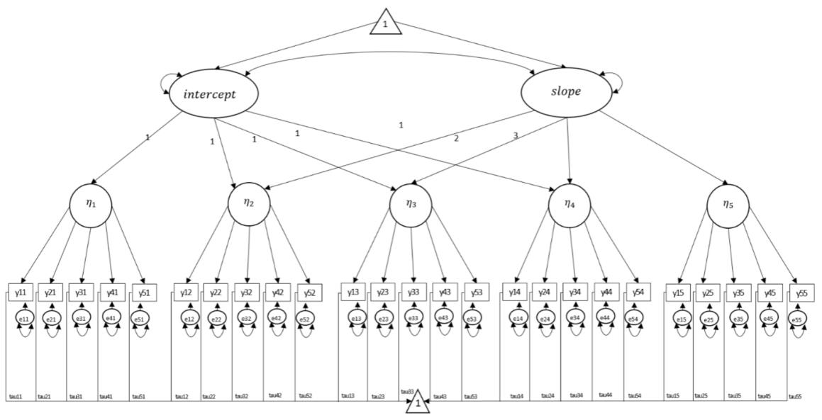
Figure 1. Path diagram of the data-generating second-order latent growth curve model (2-LGCM) for the $T=5$, $I=5$ design. Figure and mathematical expressions are adapted from Grimm et al. (2016) and Yang et al. (2021).

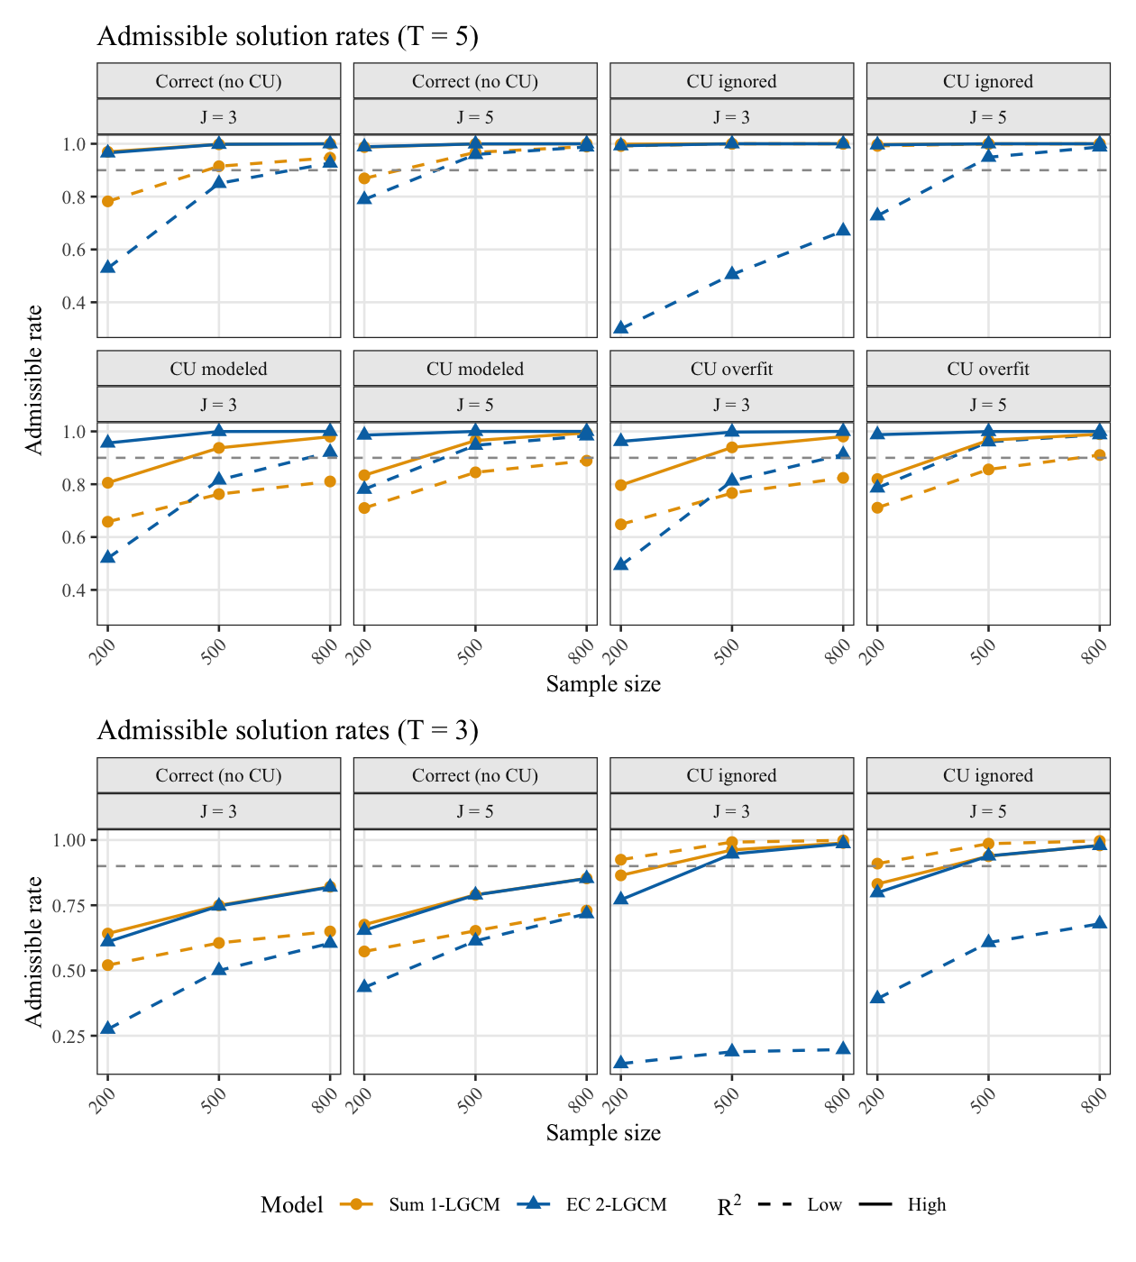
Figure 2. Admissible Solution Rates by CU Specification
Note. Admissible solution rates are proportion that converged without negative variance estimates or standardized correlations exceeding 1 in absolute value. Panels are blocked by CU specification ($T=5$ above, $T=3$ below). At $T=3$, CU modeled and CU overfit are omitted to avoid under-identification. The dashed line marks the .90 level.

Figure 3. Path diagram of the data-generating second-order latent growth curve model (2-LGCM) for the $T=5$, $I=5$ design. Figure and mathematical expressions are adapted from Grimm et al. (2016) and Yang et al. (2021).
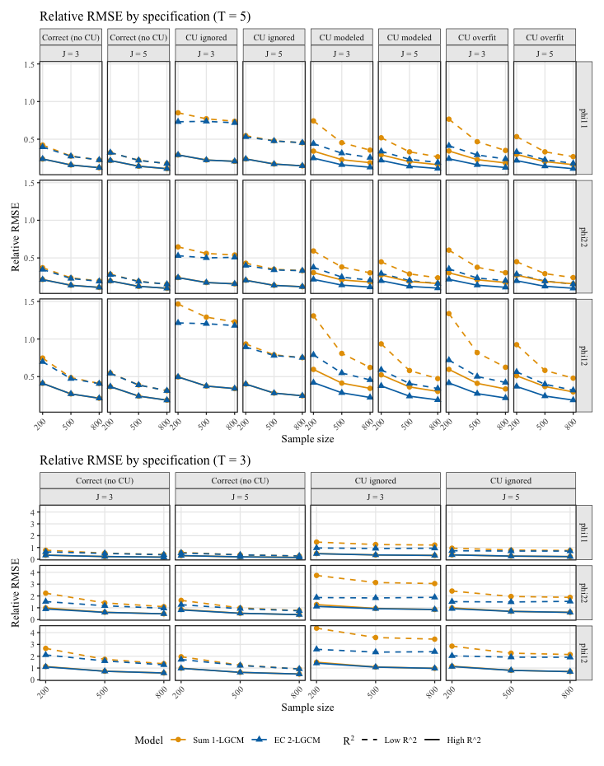
Figure 4. Path diagram of the data-generating second-order latent growth curve model (2-LGCM) for the $T=5$, $I=5$ design. Figure and mathematical expressions are adapted from Grimm et al. (2016) and Yang et al. (2021).
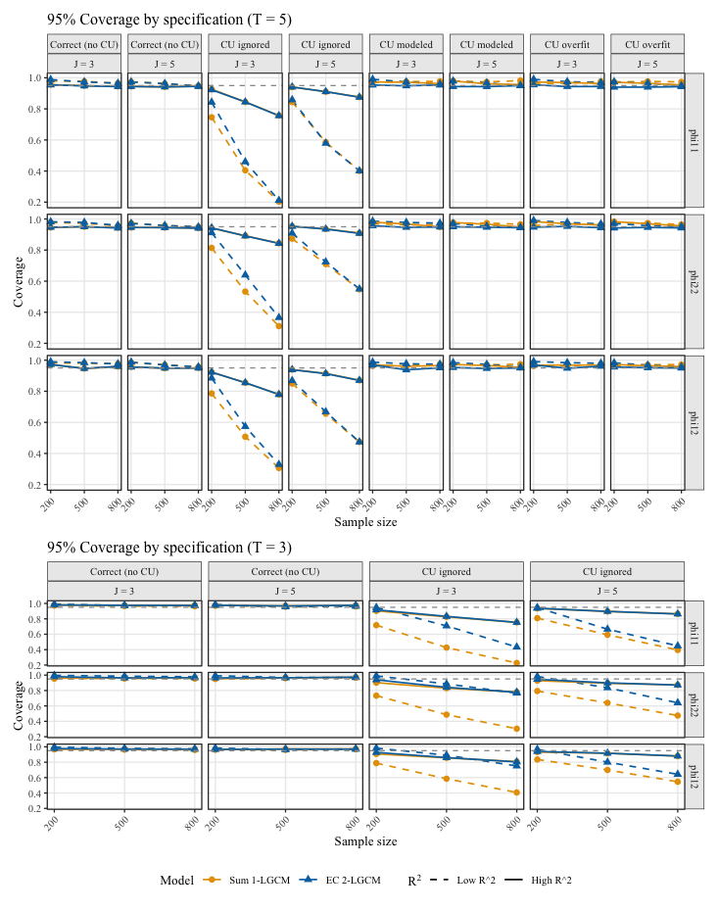
Figure 5. Path diagram of the data-generating second-order latent growth curve model (2-LGCM) for the $T=5$, $I=5$ design. Figure and mathematical expressions are adapted from Grimm et al. (2016) and Yang et al. (2021).

Figure 6. Path diagram of the data-generating second-order latent growth curve model (2-LGCM) for the $T=5$, $I=5$ design. Figure and mathematical expressions are adapted from Grimm et al. (2016) and Yang et al. (2021).

